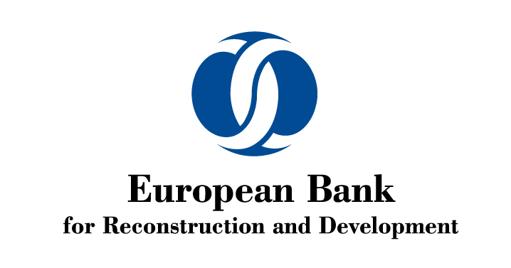
EBRD 2017 Annual Meeting and Business Forum
9-11 May. Nicosia, Cyprus

INVITATION
The European Bank for Reconstruction and Development has the honour to invite you to

Non-Performing Loan Resolution Networking Event
Date: 9 May 2017. 9:30 am
Location: Filoxenia Conference Centre, Thrakis 17, 2112 Aglantzia-Nicosia

Who should attend?
The event will provide an opportunity to representatives of commercial banks, NPL resolution platforms, NPL portfolio investors, regulatory bodies, restructuring advisors and all those involved in the process of NPL resolution to exchange experiences and information regarding investment in NPL and NPL resolution in EBRD’s region and particularly in Cyprus and Greece.
Programme:
- Introduction: Kamen Zahariev, Director Corporate Recovery, EBRD
- The Vienna NPL Initiative: Latest Developments, Bojan Markovic, Deputy Director Economics, Policy and Governance, EBRD.
- Panel discussion: Marios Kalotychos, Senior Manager, Hellenic Bank; Nick Smith, Director Restructuring & Recoveries, Bank of Cyprus; Nick Colman, Partner, Portfolio Solutions Group, KPMG; moderated by Noel Edison, Director FI, EBRD
- Central Bank of Cyprus (to be confirmed)
Followed by refreshments and networking opportunities.
EBRD Annual Meeting Day Pass: Please note that delegates attending the event will be able to receive a Day Pass for the EBRD Annual Meeting and Business Forum events on 9 May 2017.
Registration: Please RSPV to Lesley Crossley crosslel@ebrd.com

